***Dhanush Kumar.K***

*731621106008*

[***dhanushksdm@gmail.com***](mailto:dhanushksdm@gmail.com)

***Git Lab Assessment 1***

Step 1: Create a local git repo with the name "MyRepo".

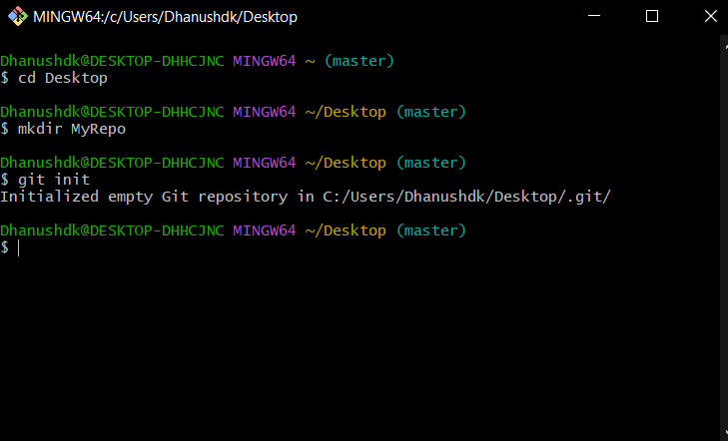

Step 2: create one .txt file, five .c files and five .java files in the working area.

Step 3: Verify the git status.

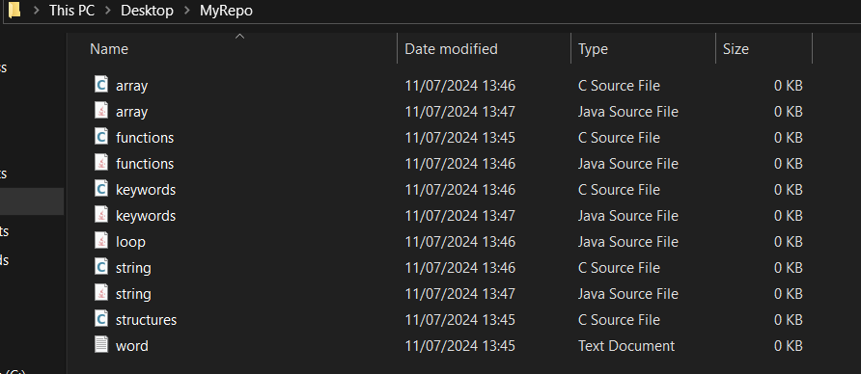

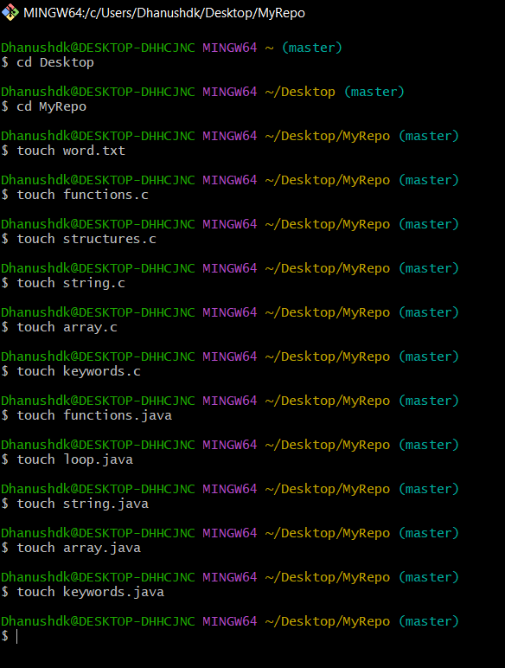

Step 4: Add only the .txt into the staging area.

Step 5: verify the git status.

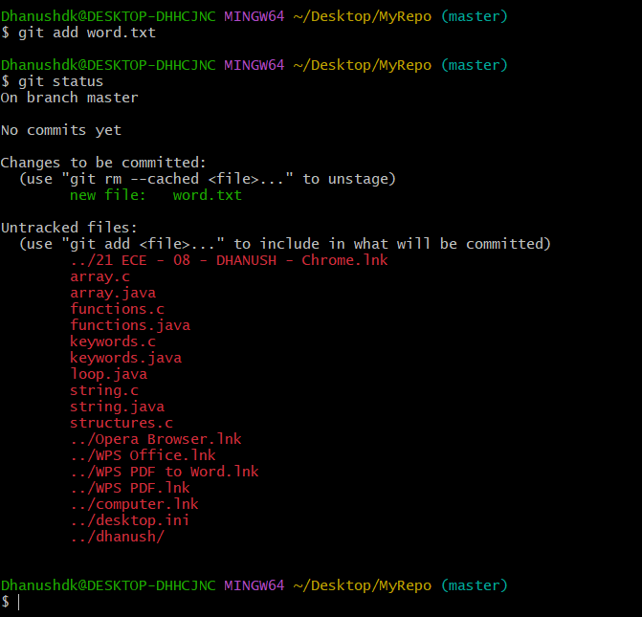

Step 6: Make a commit with the name "TXT Commit"

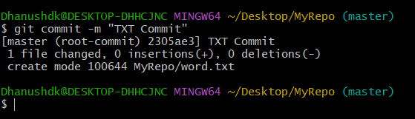

Step 7: Add all .c files into the staging area.

Step 8: verify the git status.

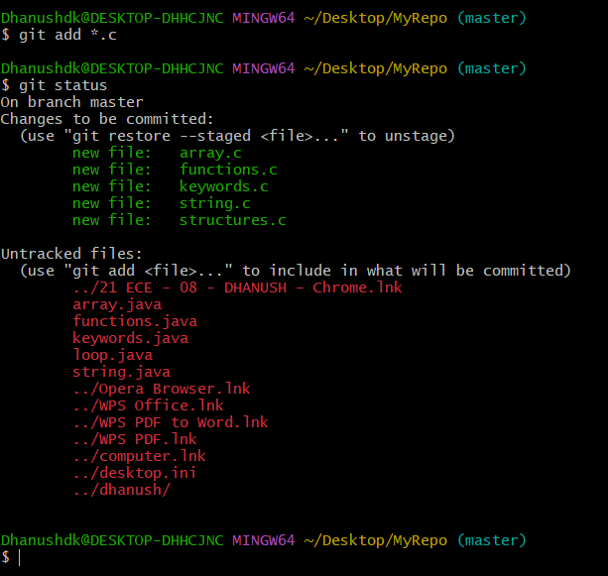

Step 9: Make a commit with the name "C Commit"

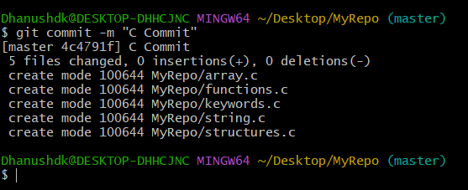

Step 10: Add all .java files into the staging area.

Step 11: verify the git status.

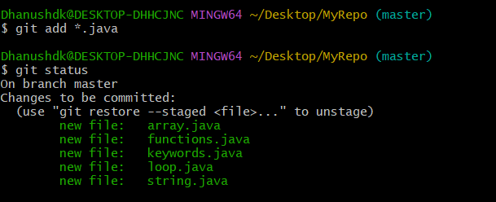

Step 12: Make a commit with the name "Java Commit"

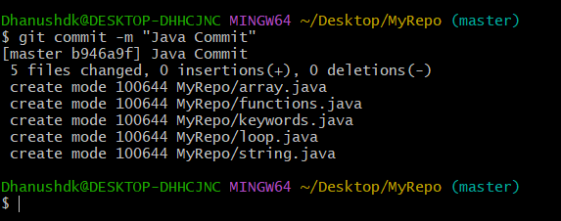

Step 13: Delete all .java files from working area.

Step 14: Now see the status.

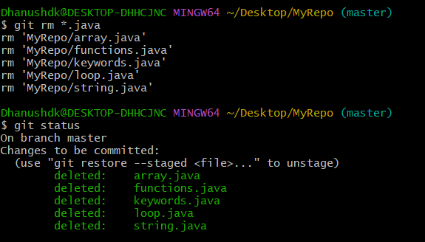

Step 15: add the changes into the staging area.

Step 16: Make a commit with the name "Delete Java Commit".

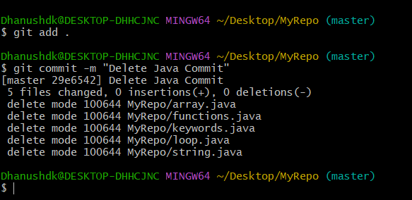

Step 17: display all commit details.



